**Assignment - 1**

**BASIC PYTHON**

|  |  |
| --- | --- |
| Assignment Date | 12.09.2022 |
| Student Name | Sheikh Ameenul Haji |
| Student Roll Number | 2019115094 |
| Maximum Marks | 2 Marks |

**Question-1:**

Split the string. s = “Hi there Sam!”

**Solution:**

lst = s.split(" ")

print(lst)

#-----------------#

#-----------------#

**Screenshot:**

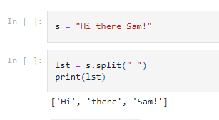

**Question-2:**

Use .format() to print the following string.

**The diameter of Earth is 12742 kilometers.**

planet = "Earth"

diameter = 12742

**Solution:**

print("The diameter of {0} is {1} kilometers.".format(planet, diameter))

#-----------------#

#-----------------#

**Screenshot:**

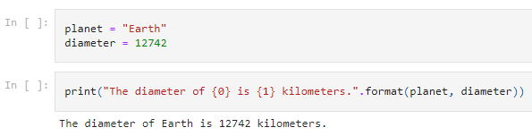

**Question-3:**

In this nest dictionary grab the word "hello"

d = {'k1':[1,2,3,{'tricky':['oh','man','inception',{'target':[1,2,3,'hello']}]}]}

**Solution:**

print(d["k1"][3]["tricky"][3]["target"][3])

#-----------------#

#-----------------#

**Screenshot:**

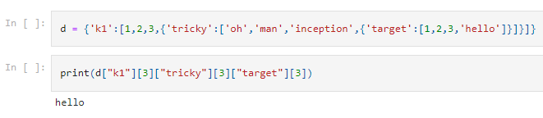

**Question-4.1:**



Create an array of 10 zeros using Numpy.

**Solution:**

import numpy as np

aZeros = np.zeros(10)

print(aZeros)

#-----------------#

#-----------------#

**Screenshot:**

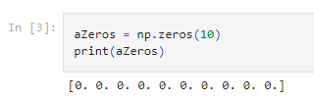

**Question-4.2:**

Create an array of 10 fives using Numpy.

**Solution:**

import numpy as np

aFives = np.ones(10)*5

print(aFives)

#-----------------#

#-----------------#

**Screenshot:**

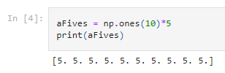

**Question-5:**

Create an array of all the even integers from 20 to 35

**Solution:**

import numpy as np

evenArray = np.arange(20, 35, 2)

print(evenArray)

#-----------------#

#-----------------#

**Screenshot:**

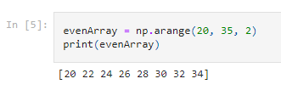

**Question-6:**

Create a 3x3 matrix with values ranging from 0 to 8

**Solution:**

import numpy as np

matrix = np.arange(0, 9).reshape(3,3)

print(matrix)

**Screenshot:**

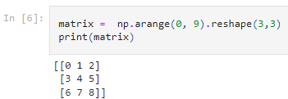

**Question-7:**

Concatinate a and b. a = np.array([1, 2, 3]), b = np.array([4, 5, 6])

**Solution:**

a=np.array([1,2,3])

b=np.array([4,5,6])

c=np.concatenate((a,b), axis=None)

print(c)

#-----------------#

#-----------------#

**Screenshot:**

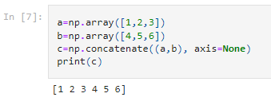

**Question-8:**



Create a dataframe with 3 rows and 2 columns

**Solution:**

import pandas as pd

df=pd.DataFrame([[1,2], [3,4], [5,6]] , columns=['column1', 'column2'])

print(df)

**Screenshot:**

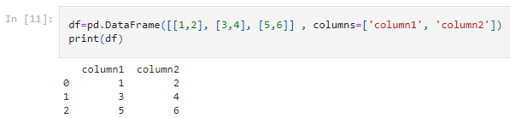

**Question-9:**

Generate the series of dates from 1st Jan, 2023 to 10th Feb, 2023.

**Solution:**

import pandas as pd

dates = pd.date_range(start="1-1-2023", end="10-2-2023")

for i in dates:

print(i)

#-----------------#

#-----------------#

**Screenshot:**

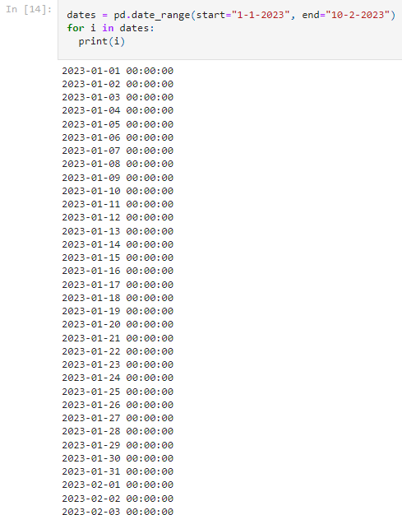

.

.

.

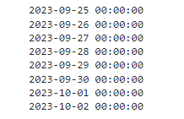

**Question-9:**

Create 2D list to DataFrame.

lists = [[1, 'aaa', 22], [2, 'bbb', 25], [3, 'ccc', 24]]

**Solution:**

import pandas as pd

lists = [[1, 'aaa', 22], [2, 'bbb', 25], [3, 'ccc', 24]]

df1=pd.DataFrame(lists, columns=['col1', 'col2', 'col3'])

print(df1)

#-----------------#

#-----------------#

**Screenshot:**

